📘 Water Potability Prediction Using Machine Learning

Abstract
Access to clean drinking water is critical for human health. Contaminated water can cause serious illnesses, including gastrointestinal disorders, infections, and long-term organ damage. Traditional water quality testing is often time-consuming, expensive, and resource-intensive. This project applies machine learning techniques to predict water potability using physicochemical properties of water, including pH, hardness, chloramines, solids, sulfate, conductivity, organic carbon, trihalomethanes, and turbidity. Decision Tree and Random Forest classifiers were used to build predictive models, and performance was evaluated using accuracy, precision, recall, F1-score, and confusion matrices. Random Forest emerged as the superior model, providing higher accuracy and better feature importance insights. This study demonstrates the potential of data-driven approaches in ensuring safe drinking water and supporting public health initiatives.

1. Introduction
Water is an essential resource for life. The quality of drinking water directly affects public health. Unsafe water is linked to various diseases and can have long-term health consequences. Manual water quality testing is often limited by time, cost, and labor constraints.
Machine learning (ML) offers a data-driven approach to predict water potability efficiently. By analyzing patterns in water properties, ML models can detect unsafe water sources quickly, enabling early interventions.
In this project, we focus on predicting whether water is potable (safe to drink) or non-potable using a publicly available dataset. The study employs two tree-based models: Decision Tree (interpretable, baseline model) and Random Forest (robust ensemble method). Feature importance and model evaluation metrics are used to analyze the influence of individual water properties on potability.

2. Dataset Description
The Water Potability Dataset contains 3276 samples and 10 features. The features are:
Feature | Description
pH | Acidity or alkalinity of water
Hardness | Concentration of calcium and magnesium (mg/L)
Solids | Total dissolved solids (ppm)
Chloramines | Chloramine concentration (mg/L)
Sulfate | Sulfate concentration (mg/L)
Conductivity | Electrical conductivity (µS/cm)
Organic_carbon | Organic carbon content (mg/L)
Trihalomethanes | Trihalomethanes concentration (µg/L)
Turbidity | Water turbidity (NTU)
Potability | Target variable: 0 = Not potable, 1 = Potable
Handling Missing Values:
- pH: 491 missing
- Sulfate: 781 missing
- Trihalomethanes: 162 missing
Missing values were replaced with the mean of the respective columns to ensure a complete dataset for training.
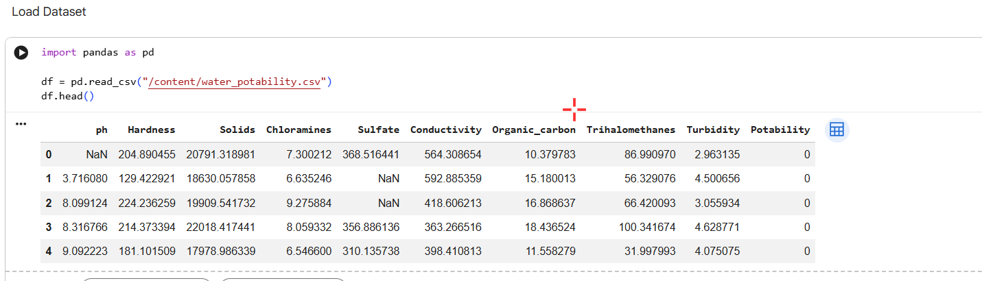
3. Methodology
3.1 Data Cleaning
- Checked for missing values and data types
- Imputed missing values with column mean
- Verified numerical consistency of all features
3.2 Exploratory Data Analysis (EDA)
- Correlation heatmap to identify relationships among features
- Histograms for feature distribution
- Boxplots to detect outliers
- Observed strong correlations between Solids, Chloramines, Hardness, and Potability
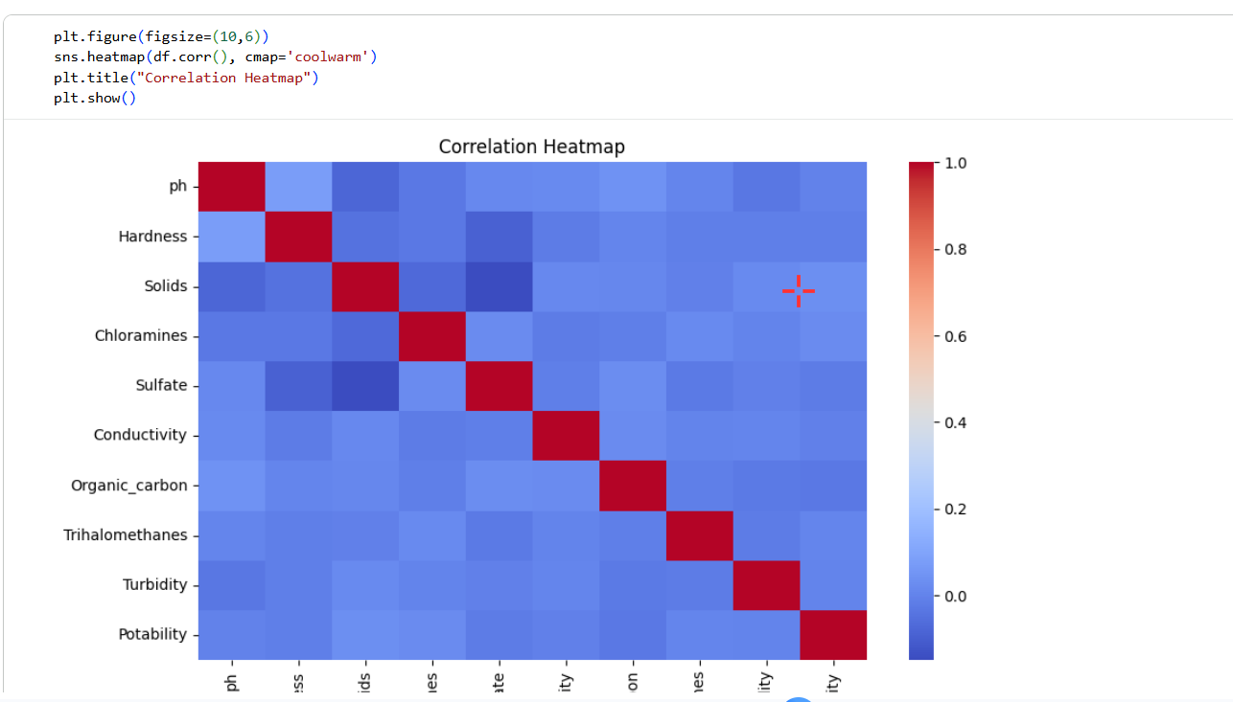
3.3 Feature Selection and Preprocessing
- All features included in modeling
- Dataset split: 80% training, 20% testing
- StandardScaler applied for normalization

4. Model Building
4.1 Decision Tree Classifier
- Simple, interpretable tree-based model
- Captures non-linear relationships
- Trained on training dataset without hyperparameter tuning
4.2 Random Forest Classifier
- Ensemble of multiple decision trees
- Reduces overfitting
- Provides feature importance metrics
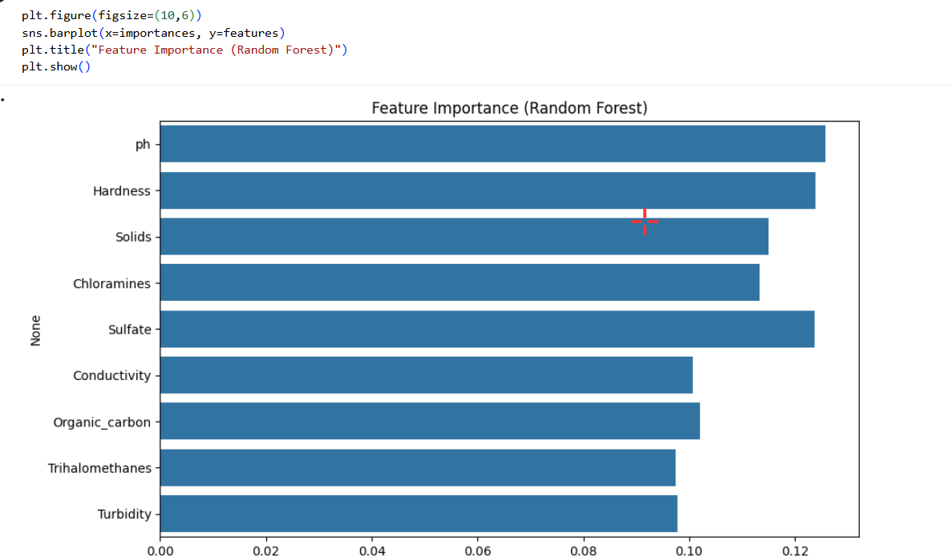
5. Model Evaluation
Model | Accuracy | Precision | Recall | F1-score
Decision Tree | 0.57 | 0.43 | 0.48 | 0.45
Random Forest | 0.66 | 0.57 | 0.34 | 0.43
Observations:
- Random Forest outperformed Decision Tree in accuracy
- Recall for potable water (class 1) is lower due to class imbalance
- Feature importance indicates Solids, Chloramines, Hardness, and pH are most influential
- Confusion matrices help visualize classification errors
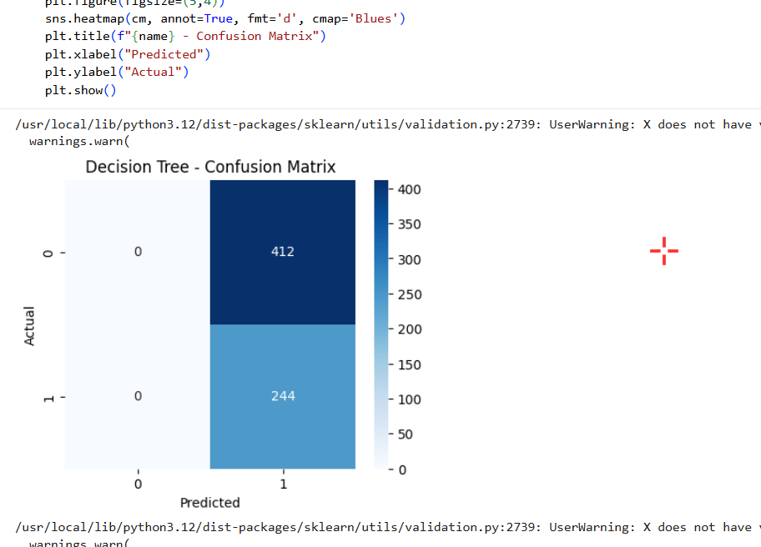
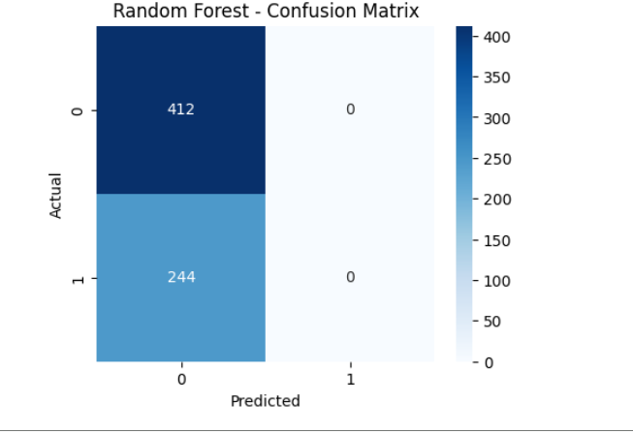
6. Discussion
- Random Forest provides more reliable predictions than Decision Tree
- Certain features significantly influence water potability
- Handling class imbalance (e.g., SMOTE) and hyperparameter tuning could improve recall and overall performance
- Model can support water quality monitoring by identifying potentially unsafe water sources quickly

7. Conclusion
This study demonstrates that machine learning can effectively predict water potability using physicochemical properties of water.
Key Takeaways:
- Random Forest is the preferred model for higher accuracy and feature insights
- Important predictors include Solids, Chloramines, Hardness, and pH
- Future work can improve model performance by addressing class imbalance, tuning hyperparameters, and testing additional classifiers
Machine learning-based prediction models can assist authorities in ensuring safe drinking water, reducing health risks, and enabling proactive interventions.

8. Tools Used
- Python libraries: pandas, numpy, matplotlib, seaborn, scikit-learn, imblearn (optional)
- Platform: Google Colab

9. Author
Shanet P Roy

